**Introduction to Power BI**

**Power BI**

Power BI is a tool for Business Intelligence and Data Visualization that assists in converting data from various sources into interactive dashboards and BI reports. It empowers users to create their own reports and dashboards without relying on IT staff or database administrators, providing self-service business intelligence capabilities.

Power BI offers a range of connectors, software, and services, including SaaS-based services and mobile apps for different platforms. These services enable business users to access data and build BI reports. It is a cloud-based service provided by Microsoft, encompassing a suite of tools for business intelligence and data visualization, such as software services, apps, and data connectors.

By utilizing the datasets imported into Power BI, we can perform data visualization and analysis to create shareable reports, dashboards, and apps. Power BI is known for its user-friendly interface, featuring convenient drag-and-drop functionality and self-service capabilities.

Microsoft offers three main platforms for Power BI:

1. Power BI Desktop: A desktop application.
2. Power BI Service: A Software as a Service (SaaS) platform.
3. Power BI Mobile: Designed for iOS and Android devices.

Furthermore, Power BI can be deployed both on-premise and on-cloud platforms.

**Process Flow of Power BI**

The process flow in Power BI paraphrased in simple and easy to understand terms:

* **Connect to data sources.** Power BI can connect to a wide variety of data sources, including Excel, SQL Server, Azure Data Lake Storage, and cloud-based services like Salesforce and Google Analytics.
* **Transform and model data.** Once you've connected to your data sources, you can use Power BI's data transformation tools to clean, filter, and shape your data. You can also create custom calculated columns and measures to help you analyze your data.
* **Create reports and dashboards.** Power BI's report designer makes it easy to create interactive reports and dashboards that visualize your data. You can use a variety of chart types, tables, and text boxes to create compelling visualizations that tell a story about your data.
* **Share your reports and dashboards.** Once you've created your reports and dashboards, you can share them with others in a variety of ways. You can publish them to the Power BI service, embed them in web pages, or share them via email or social media.

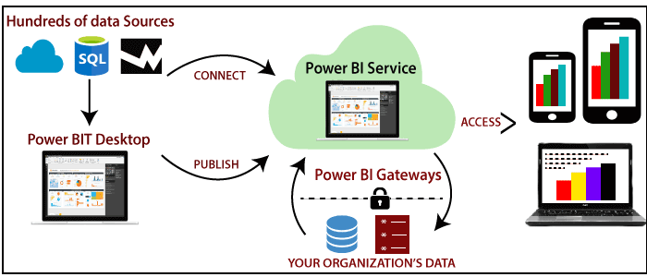

Here are some additional details about the process flow in Power BI:

* **The process flow can be customized.** The process flow in Power BI can be customized to fit your specific needs. For example, you can add or remove steps, or you can change the order of the steps.
* **The process flow can be automated.** You can automate the process flow in Power BI by using Power BI's scheduled refresh feature. This feature allows you to automatically refresh your data at regular intervals, so that your reports and dashboards are always up-to-date.

**Why Power BI?**

Power BI is a powerful tool that offers numerous benefits for data analysis and business intelligence. It provides real-time dashboard updates, ensuring that you have the most up-to-date information at your fingertips. With secure and reliable connections to cloud-based data sources, Power BI allows you to explore data using natural language queries, making it easy to extract valuable insights.

One of the key advantages of Power BI is its hybrid configuration, enabling quick deployment and creating a secure environment for data analysis. Additionally, the tool offers a wide range of features for dashboard visualization, regularly updated with contributions from the user community. It also provides pre-built dashboards and reports for SaaS solutions, streamlining the reporting process.

There are different services available within the Power BI ecosystem. Power BI Services is a cloud-based BI service that allows users to view and share dashboards, while Power BI Desktop is a desktop-based reporting interface. Power BI Embedded, running on the Azure cloud platform, provides capabilities for report creation, ETL (Extract, Transform, Load), and data analysis.

Now, let's highlight some key reasons why Power BI is an essential tool in today's business landscape:

1. **Real-time Analysis:** Power BI enables real-time analysis by establishing direct connections to data sources and keeping data updated through data refreshing, ensuring up-to-date information for informed decision-making.
2. **Custom Visualizations:** Power BI provides a diverse range of custom visualizations from a gallery, allowing users to enhance their data visualizations with a wide selection of options and categories.
3. **Quick Insights:** Power BI offers the Quick Insights feature, enabling users to swiftly explore data and discover important insights and datasets within their information.
4. **Secure On-Premises Connections:** Power BI allows secure connections to on-premises data sources like SQL Server, ensuring the safe and reliable transfer of data through data gateways. This enhances scalability and makes Power BI suitable for enterprise-level use.
5. **Integration with Other Services:** Power BI seamlessly integrates with services such as SQL Server Analysis Services (SSAS) and Microsoft Excel, enabling comprehensive analysis of data from diverse sources.
6. **Cutting-Edge Technology:** Power BI leverages advanced technologies like HTML 5.0, column store databases, cloud computing, and mobile apps, ensuring users have access to the latest features and advancements.
7. **Natural Language Query:** Power BI enables data exploration using natural language queries, making it user-friendly and accessible to non-technical users.
8. **Dashboard Visualization:** Power BI offers a wide range of dashboard visualization options, allowing users to create visually appealing and informative reports.
9. **Pre-built Dashboards:** Power BI provides pre-built dashboards for SaaS solutions, enabling quick and easy implementation of Power BI for immediate data analysis and visualization.

The most important feature of Power BI is its ability to connect to live data sources and provide real-time insights. This makes Power BI a valuable tool for businesses that need to make decisions based on up-to-date data.

In addition to the features listed above, Power BI also offers a number of other benefits, including:

* **Ease of use:** Power BI is easy to use, even for non-technical users.
* **Scalability:** Power BI can scale to meet the needs of even the largest businesses.
* **Cost-effectiveness:** Power BI is a cost-effective BI solution

In conclusion, Power BI stands out as a vital tool in the realm of business intelligence and data analysis. Its real-time updates, secure connections, user-friendly features, and integration capabilities make it an indispensable asset for organizations seeking to derive meaningful insights from their data.

**Power BI History**

**1. Conception and Development**

* Power BI was conceived by Ruler and Dhers Netz of the SQL Server Coverage Services team at Microsoft.
* West Chadic George designed Power BI in 2010 under the name "Project Crescent."
* In 2011, it was integrated with SQL Server, codenamed Mount McKinley.

**2. Preview Release**

* In September 2014, Microsoft unveiled the first preview version of Power BI.
* This preview release allowed users to get a glimpse of the upcoming capabilities and features.

**3. Initial Release**

* On July 24, 2015, the first official version of Power BI was launched.
* This release was built on Excel-based add-ins, including Pivot, View, Power Query, and Map.
* It provided users with powerful data analysis and visualization capabilities.

**4. Evolution and Enhancements**

* Following its initial release, Power BI underwent continuous development and enhancements.
* Microsoft introduced regular updates, adding new features and improving existing ones.
* These updates included enhanced visualizations, advanced data modeling capabilities, and integration with various data sources.

**5. Expansion and Adoption**

* Power BI gained popularity and widespread adoption in the business intelligence and data visualization market.
* Its user-friendly interface, extensive feature set, and integration capabilities appealed to a wide range of users and organizations.

**6. Cloud-based Services and Mobile Apps**

* Microsoft expanded Power BI's capabilities by introducing cloud-based services and mobile apps.
* These additions allowed users to access and interact with their data on-the-go, further enhancing the tool's accessibility and usability.

**7. Continued Development and Community Engagement**

* Microsoft has continued to invest in Power BI, regularly releasing updates and incorporating user feedback.
* The Power BI community actively contributes to the platform, creating and sharing custom visuals, templates, and solutions.

**8. Current Status**

* Power BI has established itself as a leading business intelligence and data visualization tool.
* It is widely used by organizations of all sizes and across various industries to analyze and present data insights.

**Timeline of Power BI History**

2006: Power BI is conceived by Thierry D'hers and Amir Netz of the SQL Server Reporting Services Team at Microsoft.

2010: West Chadic George designs Power BI under the name "Project Crescent."

2011: Project Crescent is integrated with SQL Server, codenamed Mount McKinley.

September 2014: Microsoft unveils the first preview version of Power BI.

July 24, 2015: The first official version of Power BI is launched.

2016: Power BI is expanded with new features and integrations.

2017: Power BI is made available on the cloud.

2018: Power BI Mobile is released.

2019: Power BI Embedded is released.

2020: Power BI Premium Gen2 is released.

2021: Power BI continues to evolve with new features and integrations.

Here are the recent developments in Power BI after 2021, with the year of release:

* AI-powered features: Microsoft has been adding a number of AI-powered features to Power BI, such as:
  + **AI Insights: Released in October 2021-** This feature provides users with insights into their data by automatically identifying trends, patterns, and outliers.
  + **AI Model Builder: Released in December 2021**- This feature helps users create and deploy machine learning models without having to write any code.
  + **AI Chatbot: Released in February 2022-** This feature allows users to interact with Power BI using natural language.
* New visuals: Microsoft has also been adding new visuals to Power BI, such as:
  + **Sankey diagrams- Released in October 2021:** These diagrams visualize the flow of data between different entities.
  + **Treemaps- Released in December 2021:** These diagrams visualize hierarchical data in a space-efficient way.
  + **Heatmaps- Released in February 2022:** These diagrams visualize the distribution of data in a color-coded way.
* New integrations: Microsoft has also been adding new integrations to Power BI, such as:
  + **Google Analytics- Released in October 2021:** This integration allows users to connect their Power BI dashboards to their Google Analytics data.
  + **Salesforce- Released in December 2021:** This integration allows users to connect their Power BI dashboards to their Salesforce data.
  + **SAP S/4HANA- Released in February 2022:** This integration allows users to connect their Power BI dashboards to their SAP S/4HANA data.

In addition to these specific features and integrations, Microsoft has also been making general improvements to Power BI in 2022, such as:

* **Performance improvements- Released in March 2022:**Power BI is becoming faster and more responsive.
* **Usability improvements- Released in May 2022:** Power BI is becoming easier to use, with a more intuitive interface and improved documentation.
* **Accessibility improvements- Released in July 2022:** Power BI is becoming more accessible to users with disabilities.

Overall, Power BI is a constantly evolving platform that is becoming more powerful and user-friendly with each release. The AI and ChatGPT integration ,released in September 2022, is just the latest example of Microsoft's commitment to innovation in the business intelligence space.

**Power BI Components**

Power BI consists of several components that serve different purposes in the data analysis and visualization process:

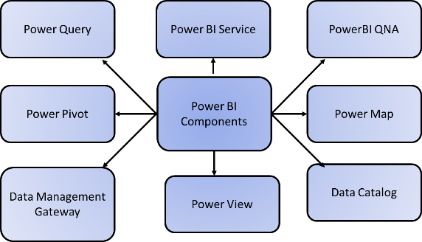

1. **Power Query:** Power Query enables users to access, search, and transform data from various public and internal sources. It provides a user-friendly interface for data preparation and cleansing tasks.
2. **Power Pivot:** Power Pivot is a data modelling component that allows users to perform in-memory analytics. It enables users to create complex data models and relationships, perform calculations, and aggregate data for advanced analysis.
3. **Power View:** Power View is a powerful visualization tool in Power BI. It enables users to analyze, visualize, and display data as interactive visualizations. Users can create interactive charts, graphs, and maps to present insights in a visually appealing manner.
4. **Power Map:** Power Map is a component of Power BI that focuses on geographical visualization. It allows users to create interactive and immersive 3D maps that bring data to life. Users can explore data on a map and analyze it from a geographic perspective.
5. **Power BI Service:** Power BI Service is a cloud-based platform where users can publish, share, and collaborate on their Power BI reports, dashboards, and datasets. It allows users to access and interact with shared content, making it easy to collaborate and make data-driven decisions.
6. **Power BI Q&A:** Power BI Q&A enables users to ask questions about their data using natural language queries. The system understands the query and provides immediate responses in the form of visualizations or data tables.
7. **Data Management Gateway:** The Data Management Gateway is a component that enables secure access to on-premises data sources. It provides periodic data refreshes, exposes tables, and allows users to view data feeds from on-premises data sources while ensuring data security and integrity.
8. **Data Catalog:** The Data Catalog helps users quickly discover and reuse queries. It provides a centralized location to store and organize queries, making it easier to find and reuse previous data transformations.

These components work together to provide users with a comprehensive suite of tools for data extraction, transformation, modelling, visualization, and collaboration within the Power BI ecosystem.

**Power BI Architecture:**

AThe architecture of Power BI can be divided into three phases, each handling different aspects of data management and visualization:

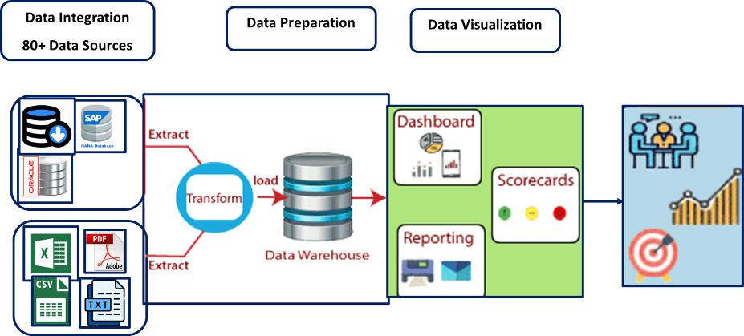

1. **Data Integration:** In this phase, data is collected from various sources, such as separate databases or servers. The data is then extracted from these sources and integrated into a standardized format. This integrated data is stored in a staging area where it can be accessed for further processing.
2. **Data Processing:** Once the data is integrated, it undergoes preprocessing to make it suitable for visualization. This involves tasks such as handling missing or redundant values in the datasets. Business rules and transformations are applied to the data to prepare it for presentation. The processed data is then loaded into a data warehouse where it can be efficiently stored and retrieved.
3. **Data Presentation:** With the processed data in place, Power BI provides a range of visualization options to present the data in an intuitive and informative manner. Dashboards and reports are used to display the data visually, allowing business end-users to gain insights and make informed decisions based on the presented information. The visual reports generated by Power BI enable users to interact with the data and explore different perspectives.

By following this architecture, Power BI enables organizations to efficiently handle and integrate data from various sources, process it for better visualization, and ultimately present it in a way that facilitates effective decision-making.

**Power BI Tools:**

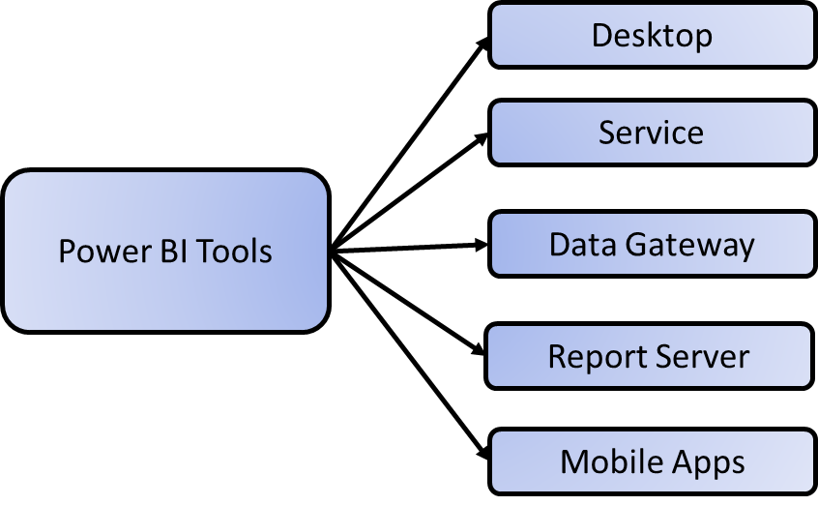

**Power BI Desktop:** This tool serves as the primary authoring and publishing platform for Power BI. Users and developers utilize Power BI Desktop to create new models and reports. It is available free of charge.

**Power BI Service:** Power BI data modules, dashboards, and reports are hosted in the cloud as a Software as a Service (SaaS). Sharing, administration, and collaboration occur within the Power BI Service. To access advanced features, a Pro license is required, costing $10 per month.

**Power BI Data Gateway:** Acting as a bridge between the Power BI Service and on-premises data sources, the Power BI Data Gateway enables data connectivity options such as Import, Direct Query, and Live Query. It is installed by a Power BI administrator.

**Power BI Report Server:** The Power BI Report Server is responsible for hosting various types of reports, including paging reports, mobile reports, KPIs, and Power BI Desktop reports. It requires updates every four months and is managed by the IT team.

**Power BI Mobile Apps:** Power BI Mobile Apps are available for Android, iOS, and Windows devices. They are managed through Microsoft Intune, providing users with the ability to view reports and dashboards directly from the Power BI Service or Report Server.

In summary, Power BI Desktop serves as the authoring tool, Power BI Service is the cloud-based platform, Power BI Data Gateway enables connectivity, Power BI Report Server hosts reports, and Power BI Mobile Apps offer mobile access to reports and dashboards.

**Building Blocks of Power BI**

Power BI has five building blocks: visualizations, reports, dashboards, datasets, and tiles.

* **Visualizations in Power BI:** Visualizations are the building blocks of Power BI. They are the graphical representations of data that can be used to tell a story or answer a question. Some common visualizations include line charts, pie charts, bar charts, and maps.

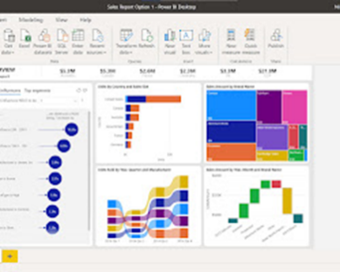

* **Reports in Power BI:** Reports are collections of one or more visualizations that are grouped together to tell a story or answer a question. Reports can be used to share data with others or to track progress over time.

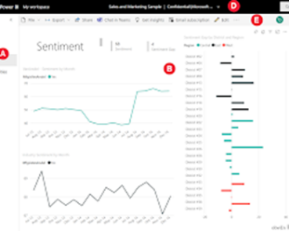

* **Dashboards in Power BI:** Dashboards are single-screen presentations of multiple visualizations. They are used to provide a quick overview of key metrics or to track data in real time.

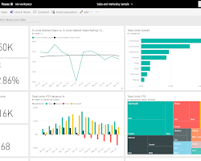

* **Datasets in Power BI:** Datasets are the raw data that is used to create visualizations and reports. Datasets can be created from a variety of sources, including Excel files, databases, and cloud-based services.

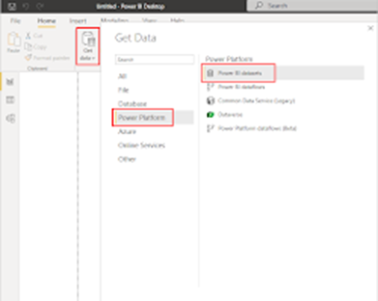

* **Tiles in Power BI:**Tiles are individual visualizations that can be embedded in reports, dashboards, or other applications. Tiles are a great way to share specific insights or to provide quick access to data.

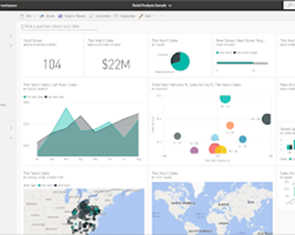

These five building blocks work together to provide a powerful platform for data visualization and analysis. Power BI can be used by businesses of all sizes to gain insights from their data and make better decisions.

**Power BI Advantages**

Power BI is a powerful business intelligence platform that can help you to analyze and visualize your data. It is easy to use, scalable, and secure, making it a great choice for businesses of all sizes. Various advantages of using Power BI are:

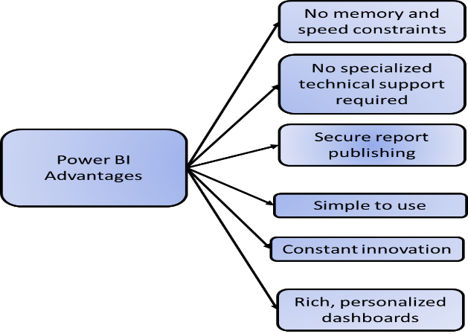

* **Secure report publishing:** You can automate the setup of data refresh and publish reports that allow all users to access the latest information.
* **No memory and speed constraints:** Shifting an existing BI system to a powerful cloud environment with Power BI Embedded eliminates memory and speed constraints, ensuring that data is quickly retrieved and analysed.
* **No specialized technical support required:** Power BI provides quick inquiry and analysis without the need for specialized technical support. It also supports a powerful natural language interface and the use of intuitive graphical designer tools.
* **Simple to use:** Power BI is simple to use. Users can easily learn it with only a short learning curve.
* **Constant innovation:** The Power BI product is updated every month with new features and functions.
* **Rich, personalized dashboards:** The crowning feature of Power BI is the information dashboards that can be customized to meet the exact needs of any enterprise. You can easily embed the dashboards and BI reports in applications to provide a unified user experience.

Here are some additional advantages of Power BI:

* **Scalability:** Power BI can scale to meet the needs of any organization, from small businesses to large enterprises.
* **Collaboration:** Power BI allows users to collaborate on reports and dashboards, regardless of their location.
* **Security:** Power BI is a secure platform that protects data from unauthorized access.
* **Integration:** Power BI integrates with a wide range of other Microsoft products, as well as third-party applications.
* **Cost-effectiveness:** Power BI is a cost-effective solution for businesses of all sizes.

Overall, Power BI is a powerful and versatile business intelligence platform that offers a wide range of advantages. If you are looking for a BI solution that is easy to use, scalable, and secure, then Power BI is a great option.

**Power BI Disadvantages**

Power BI is a powerful business intelligence platform, but it does have some limitations. One of the biggest disadvantages of Power BI is that it can be complex to learn and use. Various disadvantages of using Power BI are:

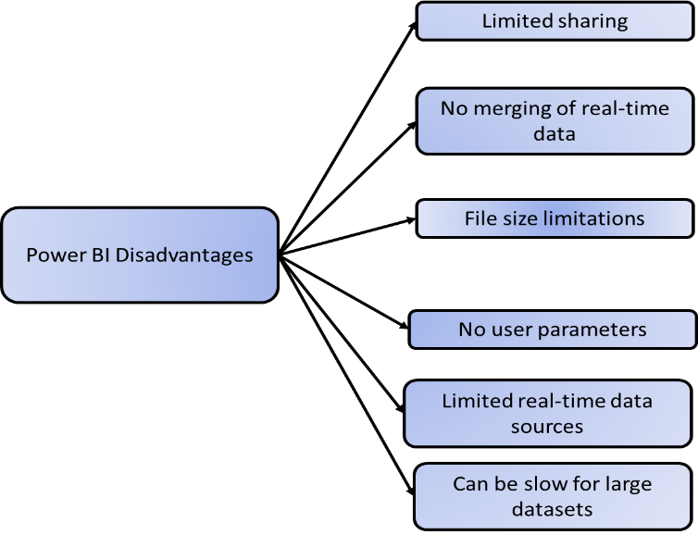

* **Limited sharing:** Dashboards and reports can only be shared with users who have the same email domain. This can be a limitation for organizations with multiple teams or departments that need to share data.
* **No merging of real-time data:** Power BI does not merge imported data that is accessed from real-time connections. This means that if you are using Power BI to track data that is constantly changing, you will need to refresh your reports and dashboards manually or use a third-party tool.
* **File size limitations:** Power BI only accepts files up to 250 MB in size. This can be a limitation for organizations that need to store large amounts of data in Power BI.
* **No user parameters:**Dashboards cannot accept or pass user, account, or any other entity parameters. This means that you cannot create dashboards that are personalized for specific users or groups of users.
* **Limited real-time data sources:** Only a few data sources allow for real-time connections to Power BI reports and dashboards. This can be a limitation for organizations that need to track data that is constantly changing.

Here are some additional disadvantages of Power BI:

* **Can be complex to learn:** Power BI has a steep learning curve, especially for users who are not familiar with data analysis or visualization tools.
* **Can be expensive:** Power BI can be expensive for organizations with a large number of users.
* **Not as customizable as some other BI tools:** Power BI does not offer as much customization as some other BI tools, such as Tableau or QlikView.
* **Can be slow for large datasets:** Power BI can be slow for large datasets, especially when performing complex calculations or visualizations.

Overall, Power BI is a powerful BI tool with a wide range of features. However, it also has some limitations, such as limited sharing, no merging of real-time data, and file size limitations. If you are looking for a BI tool that is easy to use and share, Power BI may not be the best option. However, if you are looking for a powerful BI tool with a wide range of features, Power BI is a great choice.